**Stability Analysis**

**Topics Covered**

• Stable, marginally stable, and unstable systems.

• Open-loop position and speed response of a servo.

**Prerequisites**

• Integration laboratory experiment.

• Filtering laboratory experiment.

**1 Background**

**1.1 Servo Model**

The QUBE-Servo 2 voltage-to-speed transfer function is

Ω*m* (*s*) *K*

*Pv−s* (*s*) =

*V*

*m*

= *,* (1.1)

(*s*) *τ s* + 1

where *K* = 21*.*9 rad/(V-s) is the model steady-state gain, *τ* = 0*.*15 s is the model time constant, Ω*m* (*s*) = *L* [*ωm* (*t*)] is the motor speed (i.e. speed of load disk), and *Vm* (*s*) = *L* [*vm* (*t*)] is the applied motor voltage. If desired, you can conduct an experiment to find more precise model parameters, *K* and *τ* , for your particular servo (e.g. performing the Bump Test Modeling lab).

The voltage-to-position process transfer function the same as Equation 1.1 with an integrator in series

Θ*m* (*s*) *K*

*Pv−p* =

*V*

*m*

where Θ*m* (*s*) = *L* [*θm* (*t*)] is the load gear position.

**1.2 Stability**

= (1.2)

(*s*) *s*(*τ s* + 1)

Definition for Bounded-Input Bounded-Output (BIBO) stability is:

1. A system is stable if every bounded input yields a bounded output.

2. A system is unstable if any bounded input yields a unbounded output. The stability of a system can be determined from its poles:

• Stable systems have poles only in the left-hand plane.

• Unstable systems have at least one pole in the right-hand plane and/or poles of multiplicity greater than 1 on the imaginary axis.

• Marginally stable systems have one pole on the imaginary axis and the other poles in the left-hand plane.

**2 In-Lab Exercises**

Based on the VIs already designed in QUBE-Servo 2 Integration and Filtering labs, design a VI that applies a step of 1 V to the motor and reads the servo velocity and the position as shown in Figure 2.1.

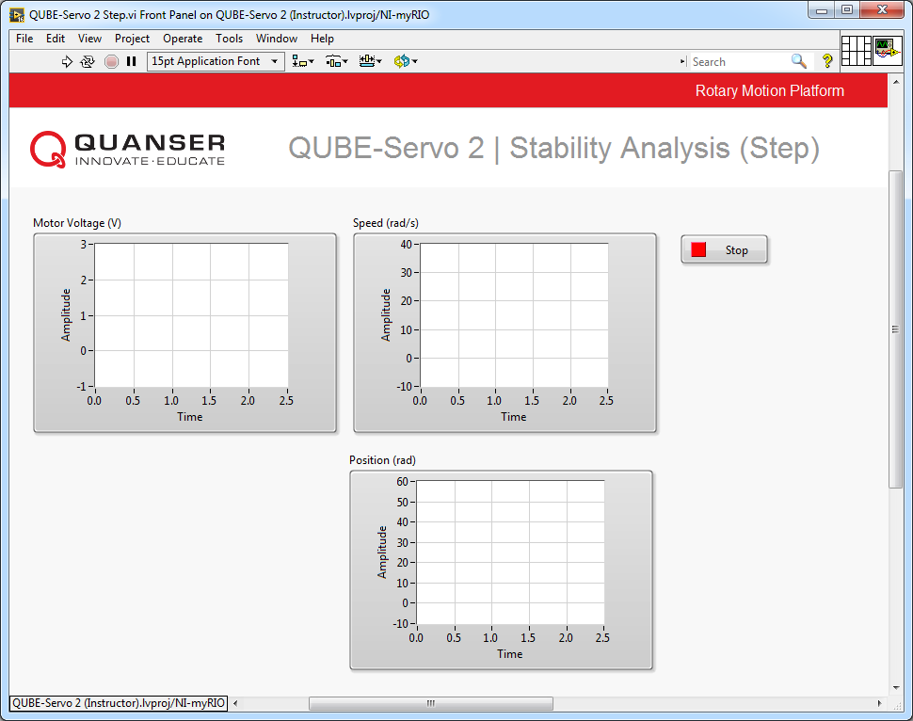

(a) Front Panel

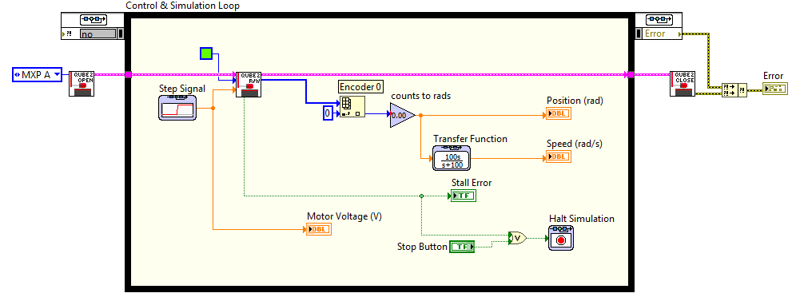

(b) Block Diagram

Figure 2.1: Measuring speed and position when applying a step

1. Determine the stability of the voltage-to-speed servo system from its poles.

2. Determine the stability of the voltage-to-position servo system from its poles.

3. Apply a unit step voltage to the servo by running the VI shown in Figure 2.1. Configure the Simulation Loop to run for 2.5 seconds. The position and speed step response should be similar to Figure 2.2.

4. Based on the *speed* response and the BIBO stability principle, determine the stability of the system. How does this compare with your results from the pole analysis?

5. Based on the *position* response and the BIBO stability principle, determine the stability of the system. How does this compare with your results from the pole analysis?

6. Is there an input where the open-loop servo position response is BIBO stable? If so, modify the VI to include your input, test it on the servo, and show the position response. Based on this result, how could you define marginal stability in terms of bounded inputs?

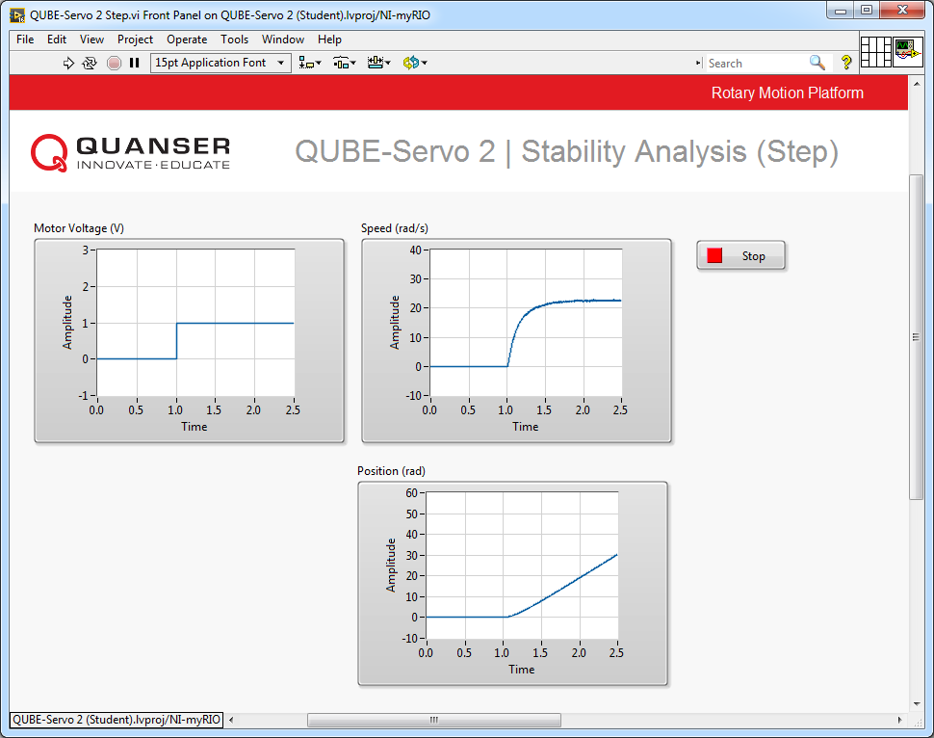

Figure 2.2: Step Response

**Hint:** Try an impulse (short step) or sinusoid input and compare the position response with the step response observed earlier.

7. Click on the Stop button to stop the VI.

© 2017 Quanser Inc., All rights reserved.

Quanser Inc.

119 Spy Court Markham, Ontario L3R 5H6

Canada [info@quanser.com](mailto:info@quanser.com) Phone: 1-905-940-3575

Fax: 1-905-940-3576

Printed in Markham, Ontario.

For more information on the solutions Quanser Inc. offers, please visit the web site at:

[http://www.quanser.com](http://www.quanser.com/)

This document and the software described in it are provided subject to a license agreement. Neither the software nor this document may be used or copied except as specified under the terms of that license agreement. Quanser Inc. grants the following rights: a) The right to reproduce the work, to incorporate the work into one or more collections, and to reproduce the work as incorporated in the collections, b) to create and reproduce adaptations provided reasonable steps are taken to clearly identify the changes that were made to the original work, c) to distribute and publically perform the work including as incorporated in collections, and d) to distribute and publicly perform adaptations. The above rights may be exercised in all media and formats whether now known or hereafter devised. These rights are granted subject to and limited by the following restrictions: a) You may not exercise any of the rights granted to You in above in any manner that is primarily intended for or directed toward commercial advantage or private monetary compensation, and b) You must keep intact all copyright notices for the Work and provide the name Quanser Inc. for attribution. These restrictions may not be waved without express prior written permission of Quanser Inc.